**B. Studies and Results**

Specific resources in the Biochemical Assay Core are state-of-the-art compound logistics and high throughput screening (HTS) infrastructure, and support for analytical chemistry, cell-based assays, and some biophysical assays. The resources are deployed as needed on a target-by-target basis and in coordination with the Project leaders of the relevant program.

**NSP5-Main Protease (Mpro) MERS-CoV / SARS-CoV-2 inhibitor screening (P4, P5)**

Robust biochemical protease screening assays for SARS-CoV-2 Mpro inhibition using quenched FRET peptide substrates were established at the beginning of the ASAP AViDD center. Building on the experience from COVID-19 Moonshot, a similar fluorogenic reagent was used for MERS-CoV Mpro. Assays were developed for iterative screening. Compounds are delivered as 20 mM DMSO stocks in ~weekly shipments from Enamine and in parallel are registered by the ASAP data core. Each compound is tested in parallel by dose-response for both MERS-CoV and SARS-CoV-2 Mpro inhibition. A well-described non-covalent inhibitor, ASAP-0000153, is used in each run as a reference control. Raw and normalized data is shared immediately with the ASAP community via the CDD ASAP Vault to provide the primary guidance for design synthesis and promotion for testing in the antiviral core for cellular activity.

These protocols have been shared on protocols.io.

* SARS-CoV-2 protocol on protocols.io: <http://dx.doi.org/10.17504/protocols.io.81wgbye9nvpk/v4>
* MERS-CoV protocol on protocols.io: <http://dx.doi.org/10.17504/protocols.io.eq2ly7r1rlx9/v4>

To-date, 1022 unique compounds have been tested in this pipeline.

While SARS-CoV-2 Mpro inhibitors perform as straightforward dose-responsive inhibitors in correlation with competitive inhibition, MERS-CoV Mpro inhibitors frequently display a bi-phasic pattern of enzyme activation at lower concentrations followed by increasing inhibition with dose (also described in PMID: [26055715](https://pubmed.ncbi.nlm.nih.gov/26055715/)). We hypothesize that low concentrations of competitive inhibitors are promoting dimerization/protease activation, however in order to facilitate the data flow we reported IC50 based on the inhibition phase (i.e. lower activity than DMSO control). Testing of cell-based activity demonstrated a correlation of this means of interpretation with antiviral activity which improved as potency of the compounds increased.

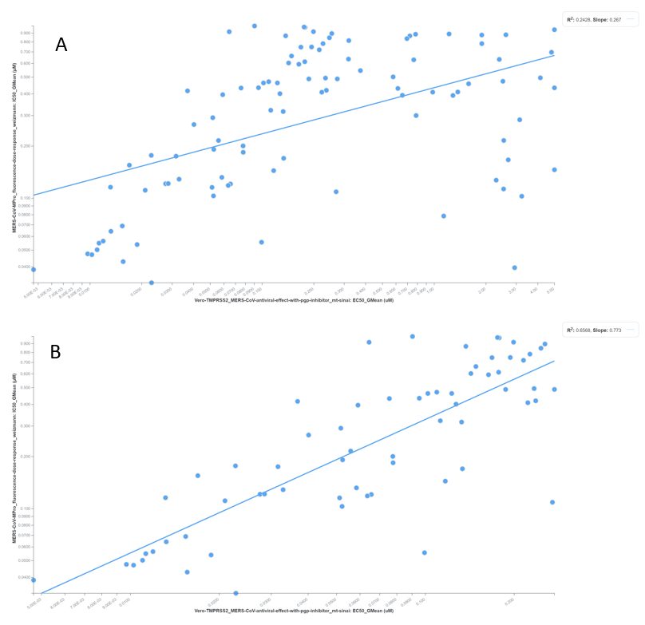

**Figure 1** - Correlation of MERS cellular antiviral activity and potency in biochemical protease assay

1. Actives IC50 < 9 µM in antiviral assay trend with biochemical potency (R2 = 0.24). **(B)** Filtering for highly active antiviral compounds (IC50 < 0.3 µM) improves the correlation (R2 = 0.65)

**NSP3 Macrodomain1 (Mac1) SARS-Cov2 inhibitor screening (P3>P5)**

Building on an assay that was published together with a fragment screen performed by P3 [<https://doi.org/10.1126/sciadv.abf8711>] we established a TR-FRET based ADPr-peptide displacement assay for screening. The compound logistics and data pipeline was identical to Mpro workflows.

The protocol is available from protocols.io at <https://www.protocols.io/view/sars-cov-2-nsp3-mac1-macrodomain-tr-fret-peptide-d-eq2ly7r2mlx9/v2>

In total, 1097 unique compounds were tested as of 25 March, 2024.

ASAP’s goal was to identify compounds that clearly engaged and inhibited Mac1 in cells, and then attempt to identify a cellular assay that showed strong antiviral activity that could be used to drive a lead optimization program. To assist in validating our biochemical assay provided a high-quality readout of Mac1 binding and inhibition, we established an orthogonal medium-throughput thermal shift assay to demonstrate direct biophysical engagement of candidate inhibitors with Mac1, as well as an ADPr hydrolase activity assay to verify on-target inhibition of the compounds of interest. These assays validated that our inhibitors were indeed engaging Mac1 and inhibiting the desired ADPr hydrolase activity, enabling us to confidently rule out issues with the biochemical assay in driving the design of potent Mac1 inhibitors.



Figure 2 - Confirmation of hit compounds by orthogonal assays. Active ASAP-0010716 and inactive enantiomer ASAP-0010715 are tested in thermal shift (A) and ADPr hydrolase (B) assays as an example of Mac1 biochemical triage cascade. Thermal shift assay is tested in single concentration (100 µM) to saturate protein for maximal shift (blue trace) compared to DMSO control (red trace).

**SARS-CoV-2 Nucleocapsid (N protein) assay development and screening (P3)**

Initial “warm starts” of the ASAP AViDD indicated that the dimerization domain of N protein could be targeted with small molecules.. Initial assay development helped discount two mechanistic premises, namely that neither RNA-dependent oligomerisation nor thermal shift were related to the mechanism being targeted, namely hyperstabilisation of dimersation. However, a set of candidate molecules based on the fragments was synthesized in early phases of the project. A collaboration with Karla Kirkegaard (P1) and Jennifer Doudna (UC Berkeley) enabled these compounds to be tested in a Virus-Like Particle (VLP) assay for functional inhibition of N protein [<https://doi.org/10.1126/science.abl6184>]. As this is a medium throughput cell-based assay, cytotoxicity could be the primary mis-interpretation of compound activity. The biochemical core screened all N protein inhibitor candidates for cell viability in parallel dose response testing in a similar cell line using a luciferase based viability assay. Compounds with a differential selectivity VLP/Cell inhibition were promoted to antiviral testing in the ASAP AViDD antiviral core.

**ZIKV / DENV NS2B/3 protease (P2>P3,P4)**

Protease assay was developed in P2 using a commercial FRET-quenched peptide substrate and transferred to the biochemical core. To reduce compound interference in assay, a custom substrate with red-shifted fluorescence was tested but did not produce a product. Compound logistics assay and data flow is as described above for other protease assays.

Two reference compounds from literature (ASAP-0015081 and ASAP-0000570) are tested to confirm run to run reproducibility.

2570 compounds have been tested in the biochemical core in Weizmann.

In order to reduce test-design-make cycle time, Bienta ltd was contracted to perform NS2B/3 DENV-2 protease assay testing in proximity to the synthetic chemists in Enamine. This is currently in production phase with selected compounds being tested in Weizmann and Bienta to confirm activity is consistent between sites.

Thermal shift assays did not show deltaTm with reference compounds, so currently there is no high throughput orthogonal biophysical assay. SPR experiments are planned for testing compounds with high aqueous solubility.

**EV-D68/A71 3C protease (P2>P3,P4)**

Protease assay was developed in P2 using a commercial FRET-quenched peptide substrate and transferred to the biochemical core. To reduce compound interference in assays, a custom fluorogenic substrate with fluorescein was produced and used for screening assays. Compound logistics, assay, and data flow is as described above for other protease assays.

Two reference compounds from literature [ASAP-0013444 (GC376) and ASAP-0012305 (Rupintrivir)] are used to confirm run-to-run reproducibility.

9029 compounds have been assayed in the biochemical core in Weizmann.

Thermal shift assay protocols have been developed and validated with reference compounds for both proteases.

In order to reduce design-make-test-analyze (DMTA) cycle time, Bienta Ltd was contracted to perform EV-A71 3C protease assay testing in proximity to the synthetic chemists in Enamine. The assay protocol was tested and performs as expected, however substrate reagent supply is delayed from supplier with confirmation expected by 14th April, 2024.

Covalent compounds from P4 have been tested in biochemical screening and are being tested for labeling by intact protein mass spectrometry.

**C. Significance**

The significance of the biochemical core activities are best viewed in the context of the novelty of the targets and the efforts to develop anti-virals. ASAP AViDD organizational structure resembles a goal-driven biotech. The biochemical core sits on the infrastructure of the Israel National Center for Personalized Medicine which also provides industry grade services to academics, and therefore enables structure-enabled drug discovery on a scale that would otherwise not be possible.

Potent chemical probe inhibitors of the Mac1 ADPr hydrolase are soon to be disclosed as chemical probes with the corresponding information regarding assay protocols, reagents and chemical triage. Regardless of antiviral efficacy, this reflects a blueprint for novel inhibitor discovery of biological processes mediated by ADPr post-translational modifications.

**D. Plans**

**MERS-CoV/SARS-CoV-2 Mpro protease inhibitor screening (P4, P5, P6)**

Potent compounds from the Mpro project are currently approaching the target candidate profile. We will continue to support additional optimizations from P5/6 and probes from P4 with protease assays.

**SARS-CoV-2 N protein nucleocapsid assay development and screening (P3)**

Several promising compounds have shown antiviral activity. In collaboration with P1, we will set up the VLP assay for operation in our laboratory. This will enable higher throughput screening than is currently available through collaborations.

**ZIKV/DENV NS2B/3 (P2>P3,P4)**

We will set up the WNV NS2B/3 assay for evaluating the spectrum of flavivirus inhibition of specific inhibitors. Since thermal shift assays were not validated, we intend to develop additional orthogonal assays together with P2. As a first effort we will try to produce an SPR based sensor chip assay. Other alternatives for protease substrates such as a TR-FRET based probe will be explored.

Additional flavivirus serotypes (DENV-1, 3, 4) are being developed in P2. We will incorporate these in our set for selectivity testing of compounds

**EV-D68/A71 3CLpro (P2>P3,P4)**

We are currently testing EV-D68 3C covalent modifiers for intact protein labeling. If successful, we will use a known covalent compound (likely Rupintrivir) as a probe to confirm competition from compounds binding in the active site. This will be useful as an orthogonal assay.

**SARS-CoV-2 nsp13 helicase (P4)**

Helicase is a potential target for covalent modifiers of key cysteine residues. We will set up a helicase assay based on capture of the un-wound DNA strand by a “silent” oligonucleotide which will liberate the quenched strand and generate fluorescence. P4 has collected a significant library of covalent fragments which wil be used as a screening set. Hits will be confirmed by orthogonal ATP consumption assays (ADPglo) and intact protein mass spectrometry.